**Arrays- SET3**

Q1) [Write a C program for the following: Given an array A[] and a number x, check and display for all pairs in A[] with sum as x](https://www.geeksforgeeks.org/write-a-c-program-that-given-a-set-a-of-n-numbers-and-another-number-x-determines-whether-or-not-there-exist-two-elements-in-s-whose-sum-is-exactly-x/).

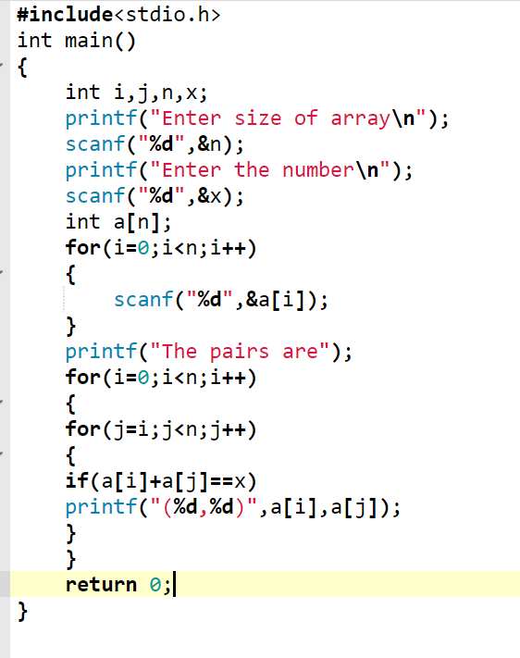

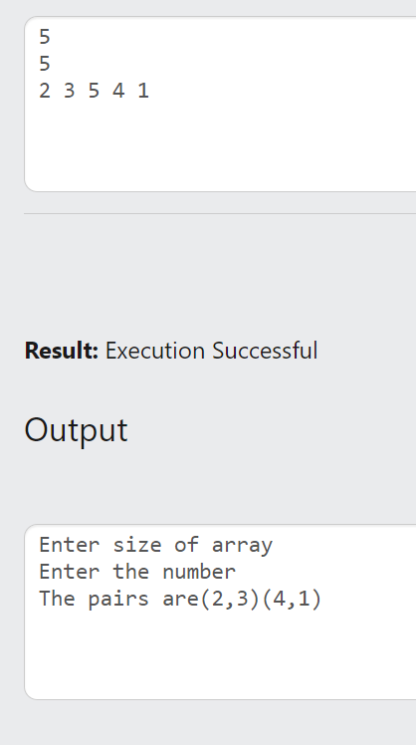

Q2) Write a C program to find minimum difference between any two elements.

Given an unsorted array **arr[]** of size **n**, the task is to find the minimum difference between any pair in the given array.

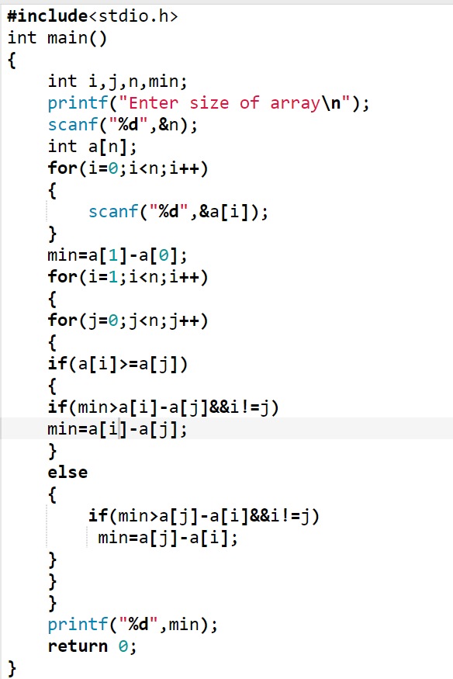

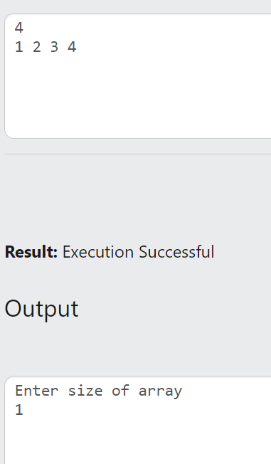

Q3) Given an array of N integers, count the total pairs of integers that have a difference of K.

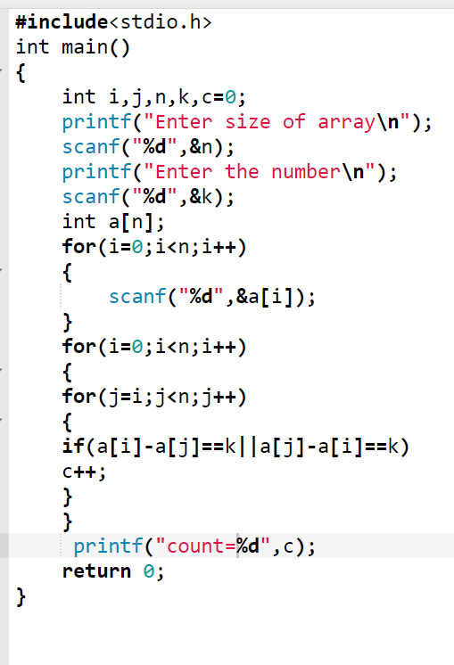

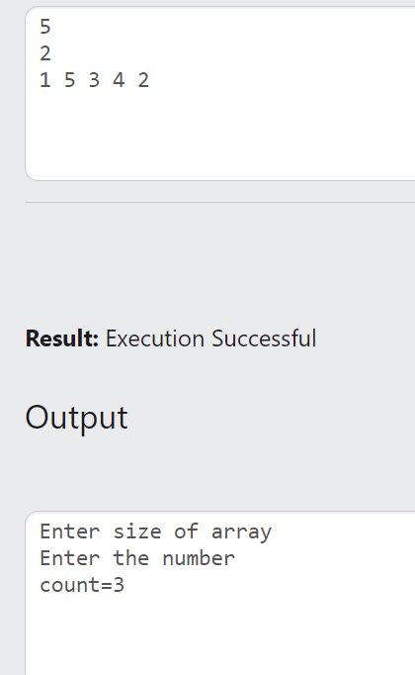

Q4) Write a C program to read n numbers into an array and to rotate the elements to the right and left as shown below: